**Activities to Build Partnerships**

A “Leader In Me” School

Grade Level Performances

Read Across America Week (March)

Purple Thursdays

Fun Run Challenge

PAC Meetings (Parent Nights)

Family Nights

ROMP Chorus

Recorder Ninjas

First In Fitness

Talent Show

Special Olympics

5th Grade “SWIM UP” Celebration

Leadership Day

Leadership Club Days

# **What is a Family-School Compact?**

A Family-School Compact is an agreement between parents, students and staff. It explains how families and staff members will work together to make sure all students get the support they need to reach grade level standards.

Description: j0332680

**Working Together “At The Lake”**

Parents, students and staff are committed to working together so the Family-School Compact is a working document. It will be posted on the Lake Myra website. Parents are encouraged to make comments and /or offer suggestions throughout the year. The compact will be shared and reviewed yearly based on feedback and collaboration.

**Grade Level Standards and Benchmarks**

A **Quarterly Newsletter** will be shared with parents to explain expectations and benchmarks for all academic areas. This newsletter will provide parents with specific details including important dates for upcoming school activities, learning resources, games, sites and apps, and other ways to support learning These will also be posted on the Lake Myra Website throughout the school year.

**Family-School Compact**

**Grade 2**

**1300 Elk Falls Drive**

**Wendell, NC 27591**

**Phone**: 919-365-8990

**Website**: http://lakemyraes.wcpss.net

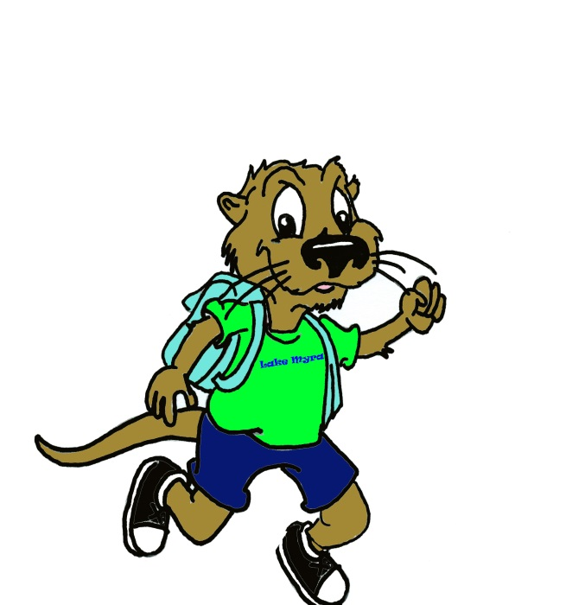

**4**

**Leaders At The Lake**

**Communication: Student Learning**

Lake Myra is committed to frequent two-way communication with families about children’s learning. Some of the ways you can expect to communicate with us are:

* Daily/Weekly Folders (depending on grade level)
* Notes From The Teacher (written and email)
* Phone Calls
* Lake Myra Website/Classroom Website
* Interim Reports
* MClass Parent Reports for Literacy
* Report Cards (Quarterly)
* Informal and Formal Parent Conferences
* Student Led Conferences

**Lake Myra Elementary Year Round School (Track 4)**

Sample

Planning Tool

**In the 2nd grade your child will be learning:**

* To read and answer questions in complete sentences with a more complex text.
* To retell key information or ideas from both nonfiction and fiction text.
* To create written responses to texts that include opinions, lessons learned, morals, character analysis, and recall of sequence of events
* To read fluently meeting grade level benchmarks
* To solve word problems using addition and subtraction facts, measurement, and money
* To use place value with three digit numbers to add and subtract
* To build, draw and analyze shapes to understand geometry and fractions

**Students**

**As a student, I promise to…**

Complete all classwork and homework assignments using my best effort.

Read nightly and discuss what I read with my parents.

Participate in activities that help me learn at home and school.

Ask questions if I need help and help others when I can.

Be responsible with materials and equipment.

Take responsibility for my actions and behavior each day.

Show leadership by making good choices and doing what is right.

**At Home**

**As a parent I promise to …**

Schedule a time to complete school related assignments.

Talk with my child daily about his or her school experiences.

Attend conferences, meetings and activities at the school.

Help my child understand and follow SWIM expectations.

Talk about and learn about the 7 Habits to encourage Leadership.

**In The Classroom**

**As your child’s teacher I promise to…**

Provide motivating and research based best practices to teach all students.

Provide open communication (folders, conferences, phone calls, emails, and notes)

Provide materials that are relevant, interesting and motivating.

Help parents understand instructional practices, class expectations and grading policies.

Provide a safe, welcoming environment that promotes learning and encourages a partnership with the school.

Provide workshops, newsletters, and information that allow parents to learn how to help their students.

## **WCPSS Goals**

## Increase Achievement

Inspire Leaders

Impact Lives

## **Lake Myra Instructional Overview**

**Daily Learning Includes:**

* The 7 Habits-The Leader In Me
* Bloom’s Taxonomy and Marzano’s Dimensions of Thinking
* Technology Integrated
* Interventions and Digging Deeper Assessments for students below benchmark

**Literacy:**

* Classroom Leveled Libraries
* Writer’s Workshop Framework
* Reader’s Workshop-Guided Reading, Learning Stations, Letterland Phonological Awareness/ Phonics-K-2,
* Vocabulary Notebooks-Content

**Math**

* Problem Solving Emphasis using calculators and manipulatives regularly
* Math Talk
* Math Workshop and Stations
* 8 Mathematical Practices

**Teachers, Parents, Students – Together for Success**

**Goals for Student Achievement**